**np.random相关操作**

groupby object .to_frame()

to_datetime()

一些基本numpy matrix 操作

<https://www.1point3acres.com/bbs/thread-680805-1-1.html>

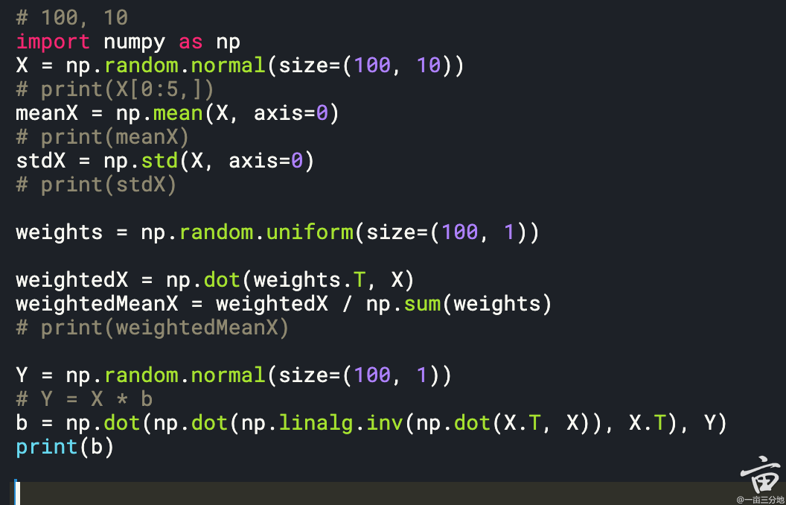

Q5: weighted monthly average market cap per company

The way C calculates and populates the monthly total volume (to be used the denominator for weights) for each company is pretty clean

```

df_company['total_dollar_volume'] = df_company.groupby(['year', 'month','company_id'])['dollar_volume'].transform('sum')

df_company['weight'] =df_company['dollar_volume'] / df_company['total_dollar_volume']

```

Q5: subset the top 5 company

This is also very creative.

```

# top 5 by month

df_sorted = df_weighted.sort_values(by=['year', 'month','weighted_mkt_cap'], ascending=[True, True, False])

df_top = df_sorted.groupby(['year', 'month']).head(5)

```

**Last observation carry forward in pandas**

<https://www.1point3acres.com/bbs/thread-296384-1-1.html>

<https://stackoverflow.com/questions/32533722/last-value-carried-forward-in-pandas>

**Value_Count > a certain number**

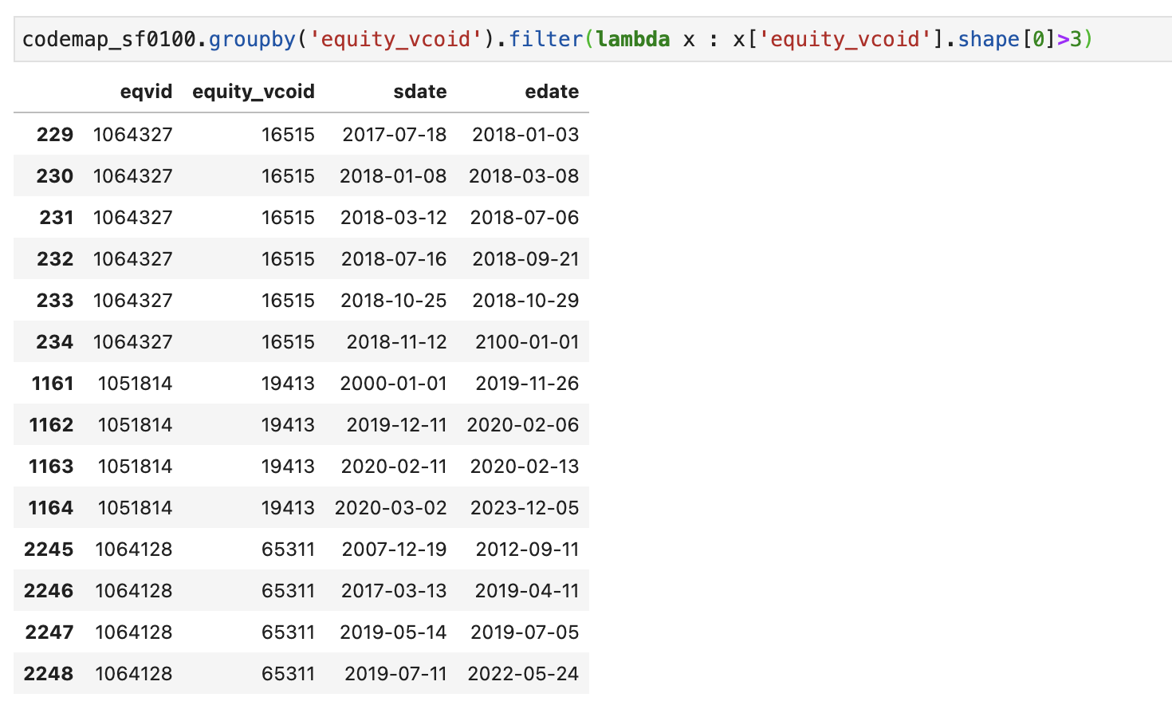

**Certain Value in one df, but also in / not in another**

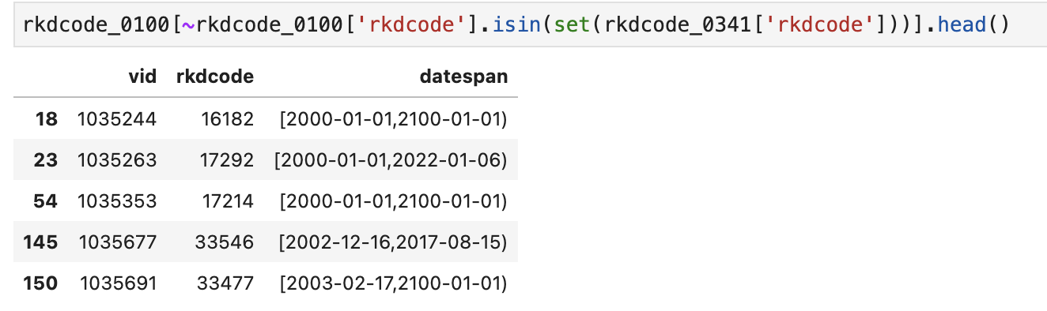

**A merge example, on, how, suffixes**

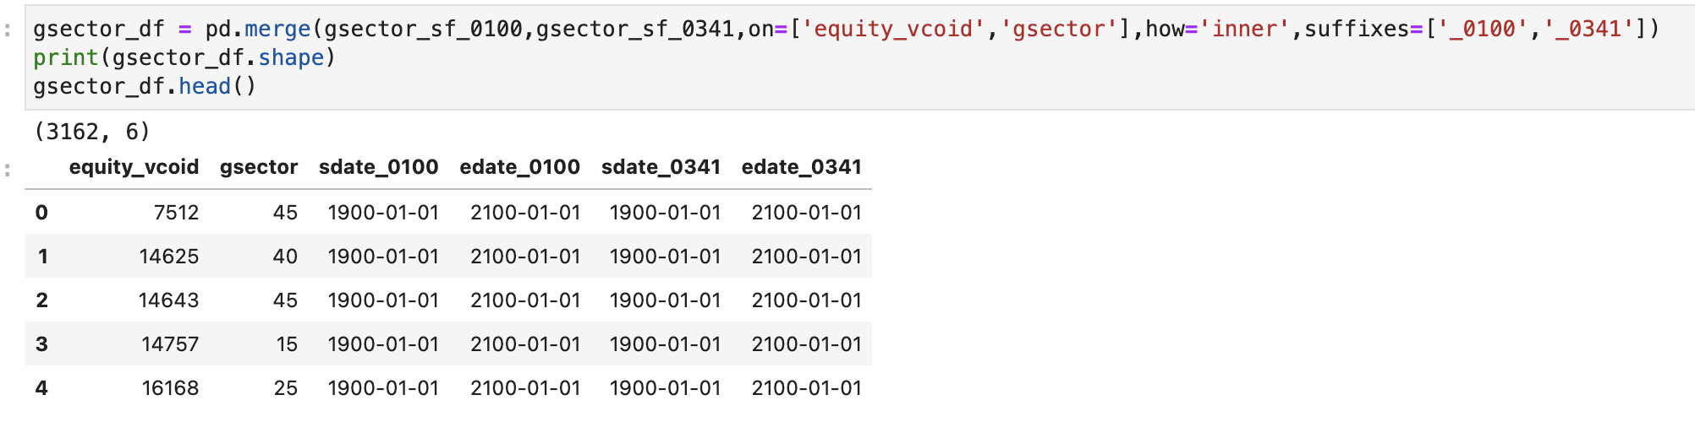

**Apply Lambda Function**

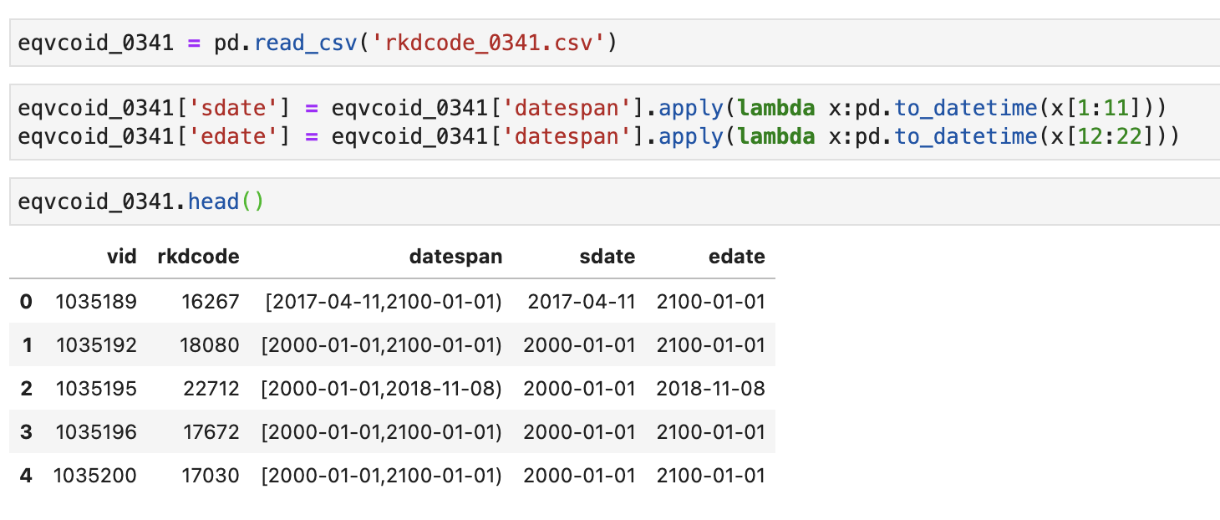

**Count the number of certain situations**

**丝滑小连招**

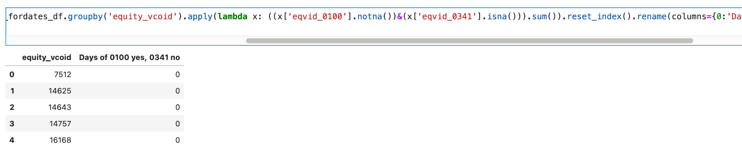

**reset_index(), rename(columns={‘old’:’new’})**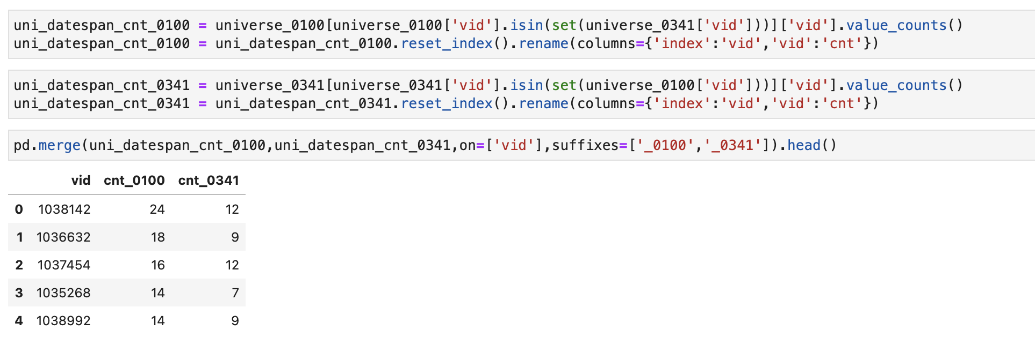

**.drop(columns=['datespan'])**

**df = df.assign(column_B=df.column_A)**

**画图，改x&y轴名字**

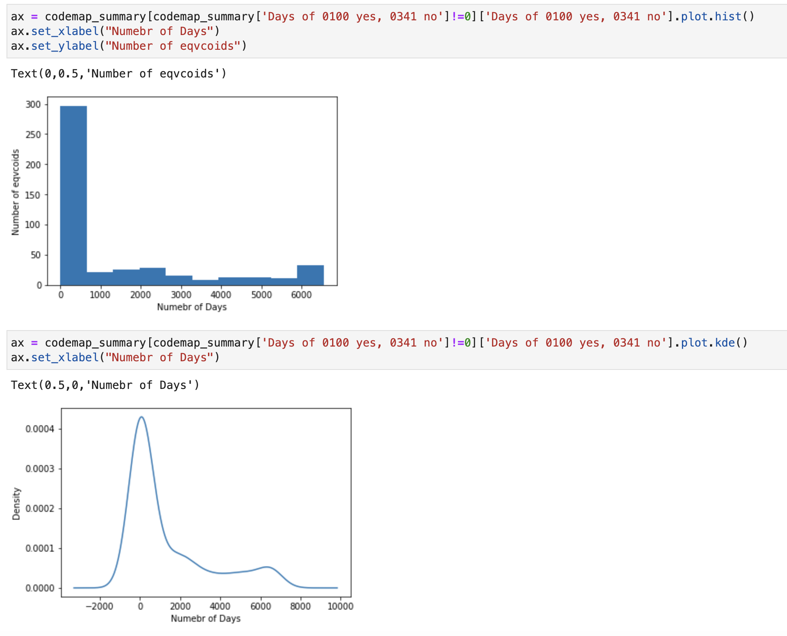

**df.describe()**

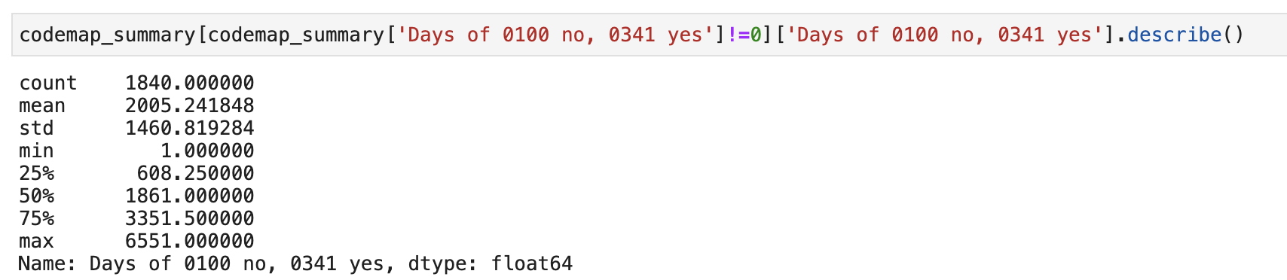

**merge multiple tables at once**

